Case Study 4
Profile of M/s BT
Name of Enterprise | M/s BT
Proprietrix | RM
Constitution | Proprietary Concern
Factory Address | Yadadri Bhuvanagiri
Established | November 2019
Line of activity | Manufacturing of Cotton Towels and Poly Shirting fabric.
Udyog Aadhaar/SSI Registration No.
GST

- Line of Activity
Entrepreneur engaged in Manufacturing of Cotton Towels and Poly Shirting fabric.

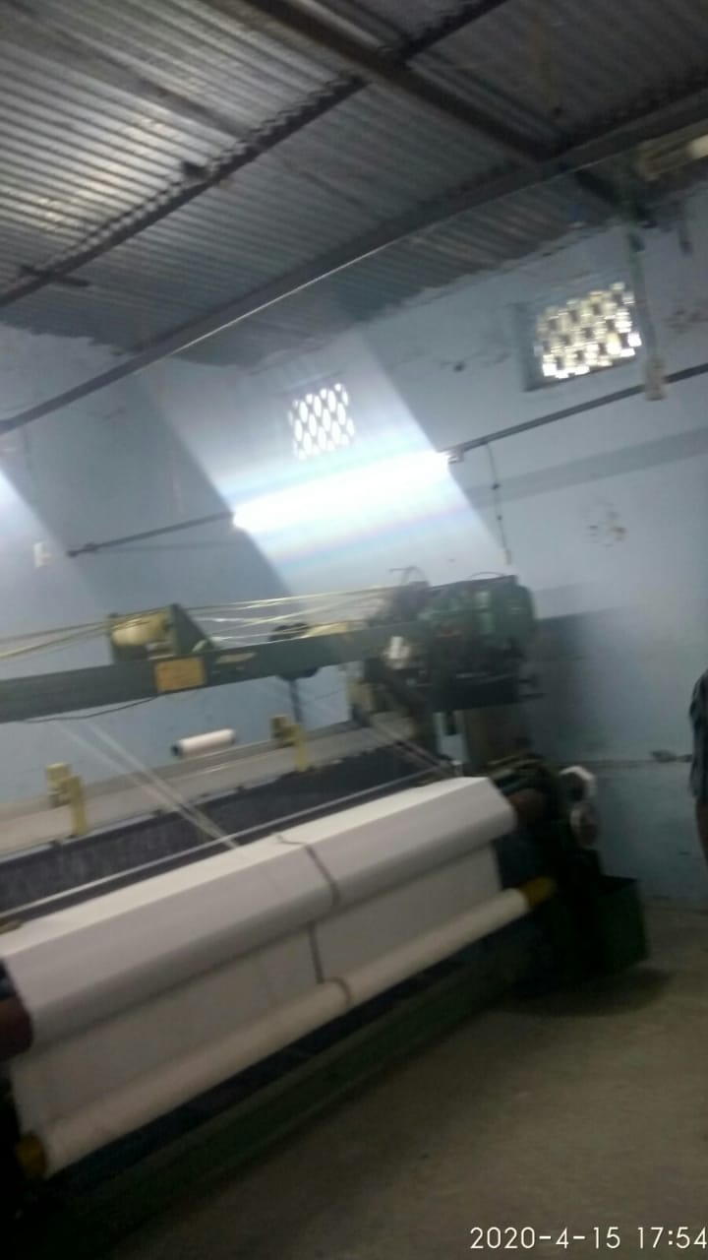

- Managerial Competencies:
RM, Proprietrix, who has been in trading so far, has approached TIHCL for getting into manufacturing. The proprietrix has enough experience in the trading of cotton towels from last 10 years. The proprietor wanted to enter in manufacturing activity by taking power looms on lease from M/s ST, a unit owned by her husband which has power looms with spare capacity. The lessor has agreed to lease out four power looms exclusively to M/s BT. She approached TIHCL for providing needed guidance for establishing the unit.
- Machinery:

The unit comprises of only weaving and warping section. The manufacturing line is restricted to Poly/Cotton fabrics and towels in dual colour. Recently, the Unit entered in to lease deed of 4 Fully Automatic Power looms. These machineries are of Rapier brand which are 100-inch looms. They have resale value in view of their wider applicability in the process. The machinery was installed in a closed premise (with proper concrete structure) and it facilitates easy movement of workforce as well as material.

- Brief History:
The Proprietrix has 10+ years of experience in trading of shirting fabric and cotton towels as well as knowledge in the manufacturing of cotton towels. The line of business has been their traditional family business and has an intention to set up power looms. Due to high cost of the looms the firm has taken 4 looms on lease and wanted to get into the manufacturing of shirting and towels. The lease agreement is from M/s Suresh Textiles where the firm is spare capacity to lease 4 looms exclusively.

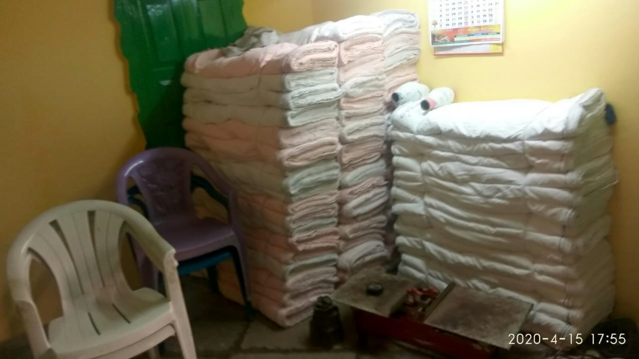
M/S BT

- Manufacturing Process:
Raw material used is yarn measured in kilograms. These yarn rolls are integrated to warping machine and will be rolled into a beam with a set programming. Then beams are fixed to each power loom and a weaving program code is setup to make to final cloth or fabric. The final product is measured in meters.
- Marketing:
- Enterprise has good potential in domestic market not only in Telangana State but also in other states of the country like MP, Orissa, UP, Maharashtra.
- BT has trading shop at Yadadri Bhuvanagiri from where he will sell their own finished goods to local buyers in wholesale market.
- Enterprise has good reputation in the domestic market.

- TIHCL intervention:
Enterprise approached TIHCL for providing needed guidance and funding for entering into manufacturing activity

TIHCL had identified and considered following for loan proposal.
- The customer has commenced the trading business of cotton towels and shirting fabric in year 2013 and has a good customer base in local market as well as inter states. Being a well experienced trader, with a view to grow their business and to create employment, Ms. Regonda Manjula has taken an initiative of manufacturing the fabric
- The unit sells the products to wholesale market.
- The customer has thorough knowledge of the market and its potential.
- The product being cotton/polyester and reasonable price, there is adequate demand for the cotton towels and poly shirting fabrics.
- Existing trading business has good sales record in the past and confident of improvising the sales in the future.
- To take it forward, she has taken 4 power looms for lease from M/s Suresh Textiles and started manufacturing of poly shirting fabric and cotton towels.
As per TIHCL assessment, we have sanctioned a composite term loan of ₹1.6 million with a moratorium of 6 months. With this funded amount unit was able to operate effectively.

Key indicators | Pre-Sanction | Post TIHCL intervention
Capacity Utilization | Into trading activity | Into Manufacturing with 50% capacity utilization on leased looms
Turnover | 2.7 million in trading | Additional turnover ₹3.50 million (Annualized)
Employment | Only proprietrix | 2

- Labor Status: (post TIHCL intervention)
Gender | Skilled | Unskilled
Men | 1 | 1
Women | 0 | 0
Total | 1 | 1

Livelihood: Enterprise created employment to 2 workers at 50% of capacity and may require another 1 or 2 workers during full capacity.

